

**Experiment No.: 05**

**Title:** To implement aggregate functions with order

by, group by, like and having clause.

**Batch:** *A-4* **Roll No.:** *16010422211*  **Experiment No: 05**

**Aim:** To implement aggregate functions with order by, group by, like and having clause.

**___________________________________________________________________________**

**Resources needed:** PostgreSQL PgAdmin4

**___________________________________________________________________________**

**Theory:**

The ORDER BY clause is used to sort the data in ascending or descending order, based on one or more columns.

SELECT column-list

FROM table_name

[WHERE condition]

[ORDER BY column1, column2, .. columnN] [ASC | DESC];

The GROUP BY clause is used in collaboration with the SELECT statement to group together those rows in a table that have identical data. This is done to eliminate redundancy in the output and/or compute aggregates that apply to these groups.

The GROUP BY clause follows the WHERE clause in a SELECT statement and precedes the ORDER BY clause.

SELECT column-list

FROM table_name

WHERE [ conditions ]

GROUP BY column1, column2....columnN

ORDER BY column1, column2....columnN

The LIKE operator is used to match text values against a pattern using wildcards. If the search expression can be matched to the pattern expression, the LIKE operator will return true, which is 1. There are two wildcards used in conjunction with the LIKE operator:

* The percent sign (%)
* The underscore (_)

The percent sign represents zero, one, or multiple numbers or characters. The underscore represents a single number or character. These symbols can be used in combinations.

If either of these two signs is not used in conjunction with the LIKE clause, then the LIKE acts like the equals operator.

SELECT FROM table_name

WHERE column LIKE 'XXXX%'

or

SELECT FROM table_name

WHERE column LIKE '%XXXX%'

or

SELECT FROM table_name

WHERE column LIKE 'XXXX_'

or

SELECT FROM table_name

WHERE column LIKE '_XXXX'

or

SELECT FROM table_name

WHERE column LIKE '_XXXX_'

Here are examples showing WHERE part having different LIKE clause with '%' and '_' operators:

| **Statement** | **Description** |
| --- | --- |
| WHERE SALARY::text LIKE '200%' | Finds any values that start with 200 |
| WHERE SALARY::text LIKE '%200%' | Finds any values that have 200 in any position |
| WHERE SALARY::text LIKE '_00%' | Finds any values that have 00 in the second and third positions |
| WHERE SALARY::text LIKE '2_%_%' | Finds any values that start with 2 and are at least 3 characters in length |
| WHERE SALARY::text LIKE '%2' | Finds any values that end with 2 |
| WHERE SALARY::text LIKE '_2%3' | Finds any values that have a 2 in the second position and end with a 3 |
| WHERE SALARY::text LIKE '2___3' | Finds any values in a five-digit number that start with 2 and end with 3 |

The HAVING clause allows us to pick out particular rows where the function's result meets some condition.

The WHERE clause places conditions on the selected columns, whereas the HAVING clause places conditions on groups created by the GROUP BY clause.

SELECT column1, column2

FROM table1, table2

WHERE [ conditions ]

GROUP BY column1, column2

HAVING [ conditions ]

ORDER BY column1, column2

**__________________________________________________________________________**



**Results: (Queries printout with output)**

1. Write 13 queries using ‘order by’, ‘group by’, ‘like’ and ‘having’ clause.

5 with normal aggregate fun,3 with clauses and aggregate function and 5 with like operator

**Example:**

1. SELECT * FROM COMPANY ORDER BY NAME, SALARY ASC;
2. SELECT NAME, SUM(SALARY) FROM COMPANY GROUP BY NAME;
3. SELECT * FROM COMPANY WHERE AGE::text LIKE '2%';
4. SELECT * FROM COMPANY WHERE ADDRESS LIKE '%-%';
5. SELECT NAME FROM COMPANY GROUP BY name HAVING count(name) > 1;

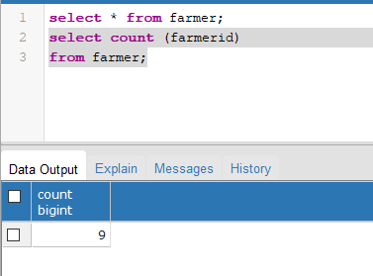

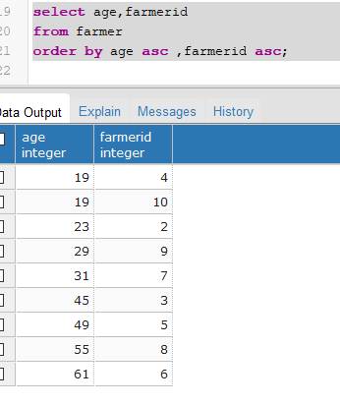



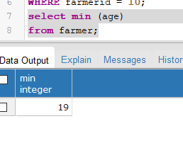

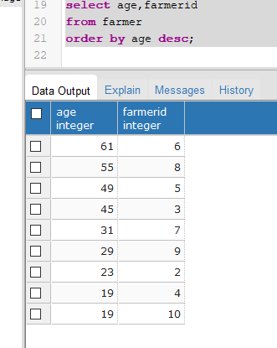

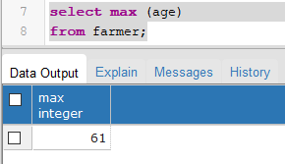

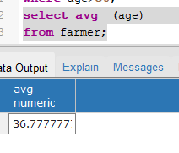

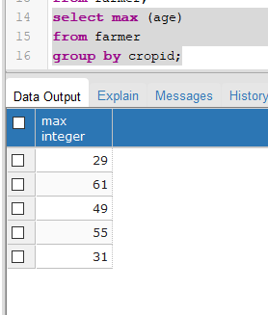

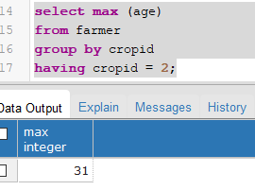

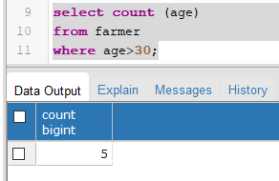

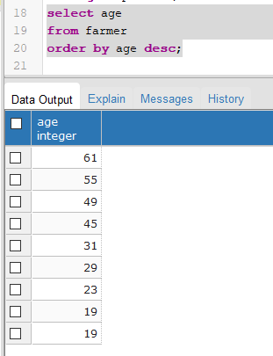

**___________________________________________________________________________**

**Outcomes:**

*Illustrate the concept of security, Query Processing, Indexing and Normalization for Relational database.*

**__________________________________________________________________________________**

**Questions:**

**Q1 Can you apply like operator on integer value? explain with example how?**

*No, LIKE operator cannot be used on integer value; instead standard comparison operators like “= , != , < , > , <= , >=” are used for integer values. LIKE operator is used for text data such as string using 2 types of wildcards (% , _). Ex of standard comparison operator: SELECT * FROM farmer WHERE age > 30. Ex of LIKE operator:*

*SELECT FROM farmer WHERE column LIKE 'farmerID%'.*

**Q2 Why aggregate functions are more used with order by, group by and having clauses? Can we change order of these clauses when used in single query**

*Aggregate functions like SUM, AVG, MIN, and MAX are commonly used with GROUP BY, HAVING, and sometimes in combination with ORDER BY clauses in SQL queries because they help perform calculations on group of rows rather than individual rows.*

*GROUP BY: This clause groups rows based on specified columns.*

*HAVING: This clause filters groups based on aggregate calculations.*

*ORDER BY: This clause sorts the result set.*

*The order is generally important because each clause operates on the result of the previous clause. However, there can be variations depending on the specific requirements of your query.*

**__________________________________________________________________________________**

**Conclusion:** *Learnt to implement Aggregate functions with order by, group by, like and having clause using pgAdmin PostGresSQL.*

**Grade: AA / AB / BB / BC / CC / CD /DD**

**Signature of faculty in-charge with date**

**__________________________________________________________________________________**

**References:**

**Books:**

1. Elmasri and Navathe, “Fundamentals of Database Systems”, 6th Edition, Pearson Education
2. Korth, Slberchatz,Sudarshan, :”Database System Concepts”, 6th Edition, McGraw –

Hill.